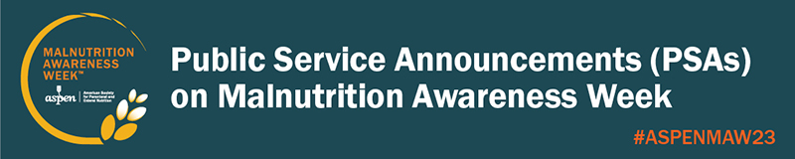

Here are five public service announcements on Malnutrition Awareness Week. Contact your local radio or television station and ask them to run one or all of them during Malnutrition Awareness Week, September 18-22, 2023. (See Quick Tips: Getting Local Media Coverage on Malnutrition Awareness Week). Please share what your local media broadcasts with ASPEN! Email stephaniel@nutritioncare.org.

- Malnutrition and the General Audience
Malnutrition is a serious health concern that affects every system in your body. It can increase the risk of infections, contribute to slow healing, result in longer hospital stays, and even increase the risk of death.
[Institution name] urges you this Malnutrition Awareness Week—September 18-22, 2023—to learn the warning signs of malnutrition, especially if you’ve been ill or hospitalized.
Visit: nutritioncare.org/KnowTheSigns.

- Malnutrition and Children or Teens
When your body does not get the right balance of energy and nutrients it needs, you can become malnourished.
Malnutrition in children and teens can impair growth and development and slow response to medical treatment.
[Institution name] urges you this Malnutrition Awareness Week—September 18-22, 2023—to learn the warning signs that your child may be malnourished.
Visit: nutritioncare.org/KnowTheSigns.

- Malnutrition and Cancer Patients
Malnutrition threatens your health and your ability to fight illness and prolongs recovery.
Those fighting cancer are especially vulnerable to becoming malnourished as treatment may make it difficult to swallow, cause diarrhea, and make one too tired to eat.
This Malnutrition Awareness Week—September 18-22, 2023—[Institution name] urges patients with cancer and those caring for them to take a close look at their nutrition intake and let their healthcare professional know if they have weight loss, impaired food intake, or diarrhea.
Visit: nutritioncare.org/KnowTheSigns.

- Malnutrition and Older Adults
Malnutrition is a serious health concern—especially for the elderly. It can increase their risk of falls and infections, contribute to slow healing, result in longer hospital stays, and even increase the risk of death.
This Malnutrition Awareness Week—September 18-22, 2023—[Institution name] asks you to look carefully at the senior citizens in your life for the warning signs they may be malnourished.
There are steps you can take to help them maintain a healthy diet and lifestyle.
Visit: nutritioncare.org/KnowTheSigns.

- Malnutrition and Economic Sense
Here are some reasons why Malnutrition Awareness Week—September 18-22, 2023—is important to [Name of your community].
Malnutrition in patients is a serious health concern that delays healing and recovery.
Hospital costs for patients with malnutrition are 73% higher than for those who are not malnourished.
[Institution name] is hosting informational programs and events all week on how to recognize, prevent, and treat malnutrition.
Visit: nutritioncare.org/KnowTheSigns.

About [Name of Institution]
[Drop in standard institution description]

About Malnutrition Awareness Week
Now in its 11th year, Malnutrition Awareness Week is an annual, multi-organizational campaign created by the American Society for Parenteral and Enteral Nutrition (ASPEN) to spotlight nutrition’s vital role in health and recovery and to educate the public on the importance of discussing their nutrition status with their healthcare professionals, especially when they are hospitalized. For more information, visit www.nutritioncare.org/MAW.

About ASPEN
The American Society for Parenteral and Enteral Nutrition (ASPEN) is dedicated to improving patient care by advancing the science and practice of nutrition support therapy and metabolism. Founded in 1976, ASPEN is an interdisciplinary organization whose members are involved in the provision of clinical nutrition therapies, including parenteral and enteral nutrition. With members from around the world, ASPEN is a community of dietitians, nurses, nurse practitioners, pharmacists, physicians, scientists, students, and other health professionals from every facet of nutrition support clinical practice, research, and education. For more information about ASPEN, please visit www.nutritioncare.org.

