**ASPEN Nutrition Science & Practice Conference**

**Abstract Reprinting/Distribution Instructions**

Below is the information on how to request permission to reprint/distribute ASPEN Nutrition Science and Practice Conference abstracts included as Supporting Information in the *Journal of Parenteral and Enteral Nutrition* (JPEN).

**To access JPEN you may;**

1. Login with your existing/new ASPEN online account information by clicking [here](https://www.nutritioncare.org/memberlogin.aspx?returnurl=https://onlinelibrary.wiley.com/journal/19412444). With this method you will have access to all ASPEN Journal content.
   1. When you have successfully logged in, you will see the message “Access by American Society for Parenteral and Enteral Nutrition” the header at the top of your screen, directly to the right of the “Wiley Online Library” header. It is highlighted in yellow in the example below.

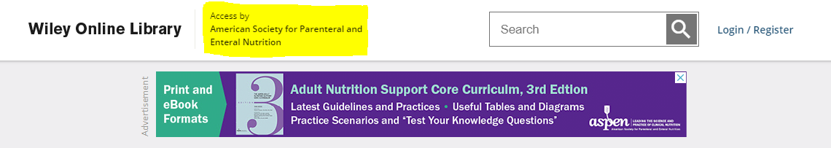

1. Or login by going directly to the [JPEN homepage](https://onlinelibrary.wiley.com/journal/19412444) via the Wiley Online Library. This method is for those who do not have an existing or wish to create an ASPEN online account.

**To access your desired JPEN journal issue**

Below are example images of the process identifying the JPEN journal issue containing the 2018 ASPEN Nutrition Science & Practice Conference abstracts.

Instructions:

* From the JPEN homepage, click on the “Browse” drop-down menu in the blue tools bar and click on “All Issues”.

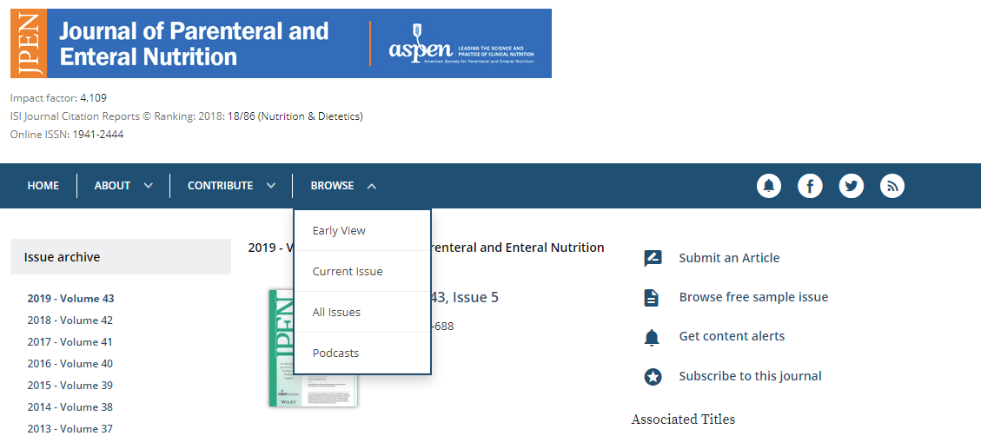

* Then on the left-hand side under “Issue Archive”, click on the year/volume of abstracts you would like to request reprint/distribution permission for.

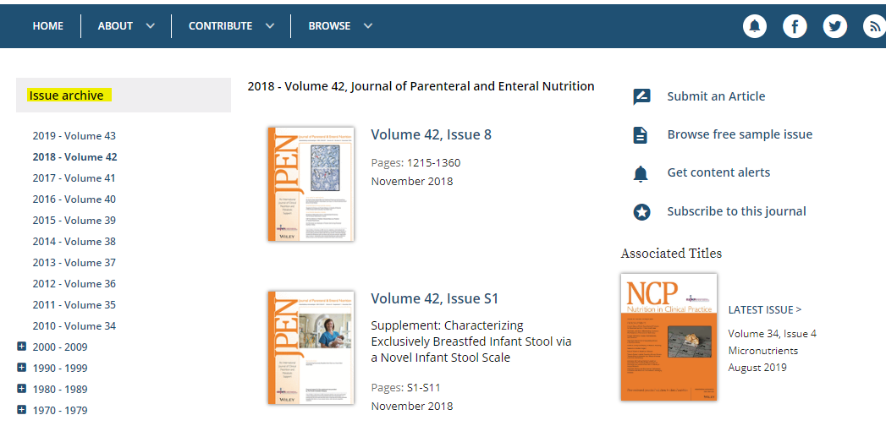

* Next, from the listed issues in the center of the page identify the issue containing the abstract supplement for that year and click on that issue. The abstract supplement will most likely be published with the February or March issue of each conference but may be subject to change.

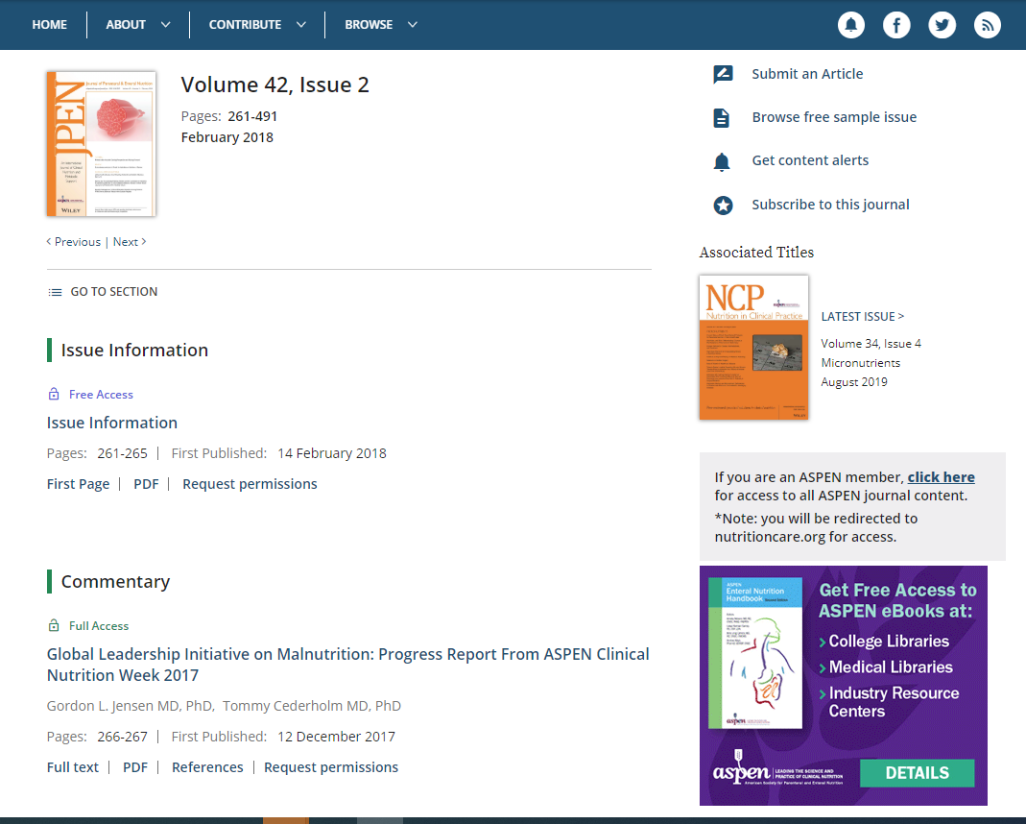

* The above steps will take you to the Table of Contents for that issue. From here, follow the steps below for requesting reprint/distribution permission for your desired abstract/s.

**There are 2 places you can access abstract permissions:**

1. From the online table of contents for the identified JPEN issue (Month/Year) containing the ASPEN Nutrition Science & Practice Conference abstract/s you would like to reprint/distribute.
2. Or from the actual abstract supplement item, as shown in 2nd example below.

**1) Table of Contents Method**

Below is an example image from the Table of Contents of the February 2018 issue (Volume 42, Issue 2).

Instructions:

* When on the table of contents scroll to the bottom of the item/section list. The abstracts will most likely be the last item on the list.
* Click on the “Request permissions” link. The yellow highlighted text in the example image.

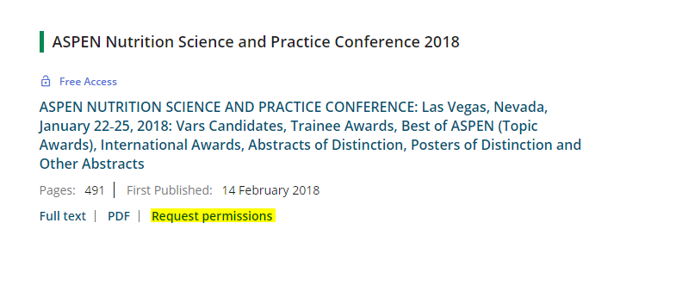

* Once you’ve clicked the”Request Permissions” button, follow the drop-down options/questions and pick the answers that best describe how you plan to use the abstract.
* When you encounter the “Portion” question, please select the “**Text extract**” option as your answer, which will include the supporting information. DO NOT SELECT ‘Abstract’.

**2) Abstract Supplement Method**

The second method is helpful if you want to view the abstract you would like to request reprint/distribution permission for.

Below is a 2018 example image of the process once you’ve clicked on the ASPEN Nutrition Science & Practice item from the Table of Contents list within the issue.

Instructions:

* Once on the page, click on the “tools” button located right above the abstract supplement description. The top, yellow highlighted text in the example image.
* From the “Tools” button a drop-down menu will appear. On the drop-down menu click the ‘Request Permissions’ button.
* Then follow the drop-down options/questions and pick the answers that best describe how you plan to use the abstract.
* When you encounter the “Portion” question, please select the “**Text extract**” option as your answer, which will include the supporting information. DO NOT SELECT ‘Abstract’.

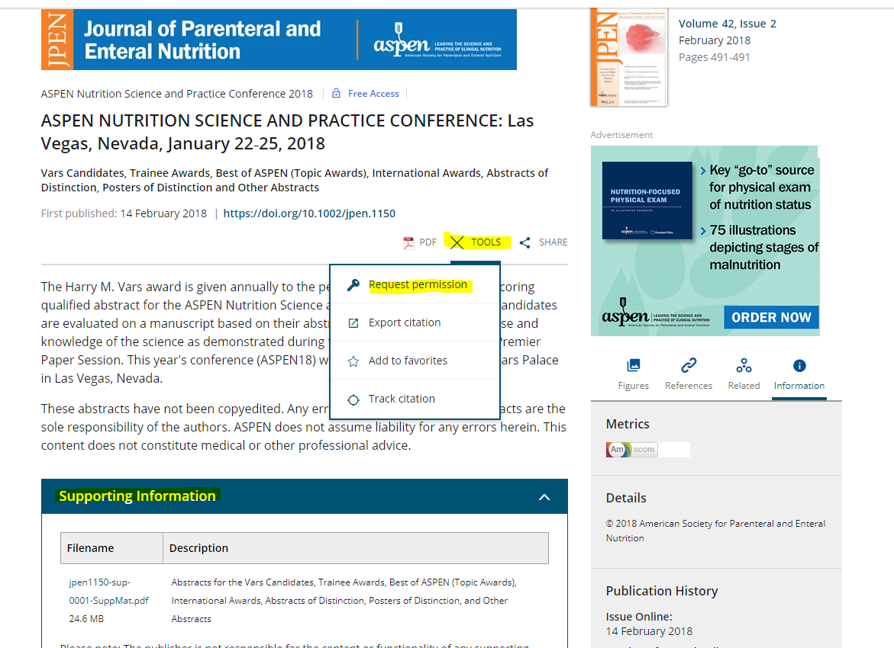

*If you encounter the following message for either method*, “Due to the nature of your request, a special order is required”,* you will need to register an account with Rights Central. In this case please contact **Rightsholder Customer Account Specialist** at

978-646-2800 Monday-Friday, 8:00AM - 5:00PM ET or [www.copyright.com](http://www.copyright.com).

**Suggested Citation Format**

Once approval is received ASPEN suggests the following citation format is used for reprinting and distributing.

Below is an example from 2018.

Joly F, Malgras A, Nuzzo A, et al. 2834193 - Characteristics of a French cohort of patients with short bowel syndrome with intestinal failure who weaned off parenteral support under teduglutide treatment (abstract). Supporting Information. ASPEN Nutrition Science & Practice Conference: Las Vegas, Nevada, January 22‐25, 2018. JPEN J Parenter Enteral Nutr. 2018 Feb;42(2):491.