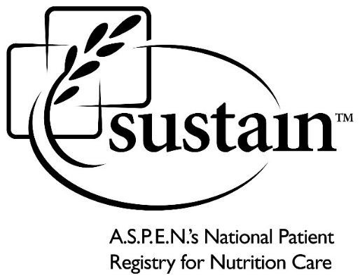
Application for Use of the Sustain Registry’s Public Use Data Sets
Eligibility
Any researcher, clinician, or other qualified investigator with a scientifically sound application is eligible to use Sustain data provided (1) the proposed analyses do not overlap with an existing proposal that has already been approved and (2) applicants comply with the processes and procedures outlined in this application. All requests for access to the public use data must be initiated by emailing a completed application to the address that is provided at the end of this document.

The Importance of Clearly Articulating the Research Question
A central aspect of the application process is a review of the research questions you wish to address with Sustain data. Therefore, your research question(s) should be clear and specific, with particular attention paid to which variables you intend to use to answer your questions. This information will help the Sustain Council ensure that the questions you wish to answer are feasible using the Sustain data. In addition, applicants are also asked to describe what will be done with results (e.g. publication, presentation, use for preliminary data for a grant application, etc).

Study documentation, including a study binder that describes the Sustain Registry, as well as data dictionaries that describe the contents of the public use data sets, are available on the Sustain website. http://www.nutritioncare.org/Using_Sustain_Data/How_to_Access_Sustain_Data/ You will need to use these tools to complete this application and to determine if your analyses are feasible. In addition, the website has a summary list of all approved analyses. This list is designed to help investigators avoid unnecessary efforts to complete a data use application for work that has already been approved for another investigator. It should be noted that because some topics are quite broad, it is likely that multiple investigators will be working on various aspects of the same topic without overlapping efforts. Should there be concerns about potential overlap, please contact Sustain staff (katyh@nutritioncare.org).

Timeframe for Application Review and Data Results
The Scientific Advisory Council typically responds to new applications within 4 weeks. Sustain data will be delivered to approved applicants within two weeks of a fully approved application, receipt of a signed data use agreement, and fee (if applicable).

Approved investigators will have 6 months of “protected time.” That is, from the time an application is approved, investigators will have 6 months to complete the work. If the proposed work is not completed in this timeframe, the Sustain Council may make the topic available to other investigators.

Standard Acknowledgment for Publications and Presentations
To ensure that that Sustain Registry is appropriately acknowledged, the following text must be included in all publications and presentations:

“The Sustain Registry is administered by the American Society for Parenteral and Enteral Nutrition (A.S.P.E.N.) with support from Baxter Healthcare, the CR Bard Foundation, the A.S.P.E.N. Rhoads Research Foundation, and more than 30 participating clinical sites across the United States. Sustain promotes utilization of its public use data sets, but it does not review or endorse specific results.”

Data Use Agreement
Following approval of the research proposal and prior to release of the public use data sets, the lead investigator must complete and sign a data use agreement, even s/he is affiliated with a site that contributes data to Sustain. The data use agreement can be found in Appendix A.

Fee for Data Use
Fees for use of Sustain data must be received prior to data set delivery. These fees are as follows:
  - Free for students and faculty at institutions that participate in the Sustain registry
  - $250 for students at non-participating institutions
  - $1,000 for faculty at non-participating institutions
  - A.S.P.E.N. will negotiate a fee associated with collaboration with non-academic institutions. Contact Katy Hanley: KatyH@nutritioncare.org.

APPLICATION INSTRUCTIONS

Application
There is no specific application form. Applicants must provide A.S.P.E.N. with all requested information in Word or PDF format.
- A cover page should include the following information
  - Project title
  - Lead investigator (title, institution)
  - Contact information (address, phone, email, fax)
  - Collaborating investigators (institutions and contact information)
- Specific aims
  - Include a clear, concise statement of research questions and testable hypotheses
- Background and significance (no more than 1 page)
- Description of proposed analyses (no more than 1 page per research question)
  - Analytic strategies
  - Specific variables (See data dictionary)
  - Timeframe (e.g. cross-sectional or longitudinal data; see Study Binder)
- Supporting literature (no more than 15 citations)
- Current CV of Lead Investigator
Submitting your Request
Although applicants may submit only one request at a time, these requests may contain more than one research question as long as the questions are closely related and do not overlap with previously approved work. E-mail the completed application to Katy Hanley (katyh@nutritioncare.org).

APPENDIX A

SustainTM, LLC
Sustain Public Use Data Set Data Use Agreement

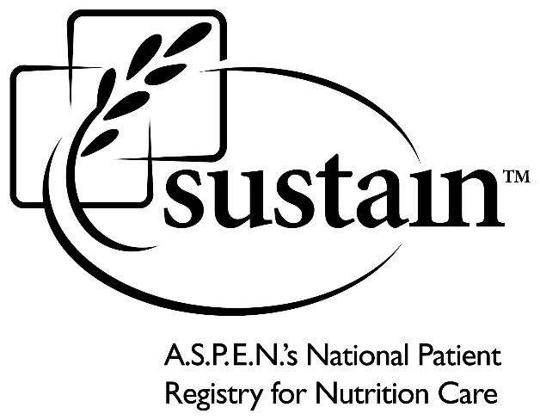

THIS DATA USE AGREEMENT (the “Agreement”) is made and entered into by and between SustainTM, LLC, an Illinois limited liability company that is a wholly owned affiliate of the American Society for Parenteral and Enteral Nutrition (“Sustain”), and the individual identified below (“User”).
WHEREAS, A.S.P.E.N. is a not-for-profit, tax-exempt association whose purpose includes the improvement of patient care by advancing the science and practice of nutrition support therapy; and
WHEREAS, A.S.P.E.N. has established and owns Sustain, LLC, a national nutrition care registry to gather data to maintain a prospective, longitudinal nutrition therapy patient registry for the purpose of improving patient outcomes (“Registry”); and
WHEREAS, the first phase of the Registry will collect information regarding patients and populations who require home parenteral nutrition in the U.S. to measure outcomes, to allow institutional benchmarking against aggregated data, and publish findings; and
WHEREAS, User is an investigator from a medical center, hospital, home infusion provider, medical group, university, or other entity that desires to analyze and publish findings from Registry data (“Data”) that has been de-identified.
In consideration of the mutual covenants and premises herein contained, the parties agree as follows:

TERM AND TERMINATION

Term of Agreement. This Agreement will begin on later of the signature dates indicated in the signature blocks below and will continue until the earlier of one (1) year or when the User has completed its use of the Data. User shall notify Sustain in writing within five (5) business days of completion of the use of the Data.

Termination. Sustain may terminate this Agreement (a) immediately if it determines in its sole discretion that User has violated this Agreement; or (b) upon thirty (30) days written notice to User. User may terminate this Agreement on thirty (30) days written notice to Sustain.

Effect of Termination. Upon termination of this Agreement for any reason, User shall, within ten (10) business days, destroy the Data (in all copies and formats) in a way that renders the Data unusable, unreadable, or indecipherable to unauthorized persons through the use of a technology or methodology specified by the Secretary of the Department of Health and Human Services in the guidance issued under section 13402(h)(2) of Pub. L. 111-5.

DATA USE.

Research. User will use the Data only for “research” purposes as that term is defined in the Health Insurance Portability and Accountability Act of 1996 (“HIPAA”);

2.2 Use for Specific Research Project. User may only use the Data for the specific research project approved by Sustain and using the analysis approved by Sustain.

2.3 Limitation on Disclosure to Third Parties. User will not grant access to or disclose the Data to any other person; however, User may grant access to or disclose the Data to another person or institution only if (a) the purpose of the disclosure is to assist User in conducting the research; and (b) the User complies with Section 2.9 of this Agreement.

2.4 Compliance with Law. User will not use or disclose the Data in a manner that would violate applicable federal or state law;

2.5 General Limitation on Disclosure. User will not use or disclose the Data other than as permitted by this Agreement or as otherwise required by law. In the event User receives a subpoena or other legal demand for the Data, User will notify Sustain within five (5) business days;

2.6 Safeguards. User will use reasonable and appropriate safeguards to prevent use or disclosure of the Data other than as provided for by this Agreement, including safeguards that reasonably and appropriately protect the confidentiality of the Data whether in paper or electronic form;

2.7 Reporting. User will report to Sustain, without unreasonable delay, but in no event later than ten (10) days, any use or disclosure of the Data not provided for by this Agreement of which User becomes aware;

2.8 Data Release. Sustain has the sole discretion and authority to determine whether Sustain will release any Data to User and at all times Sustain retains the sole discretion and authority to terminate this Agreement and require User to return or destroy the Data;

2.9 Written Agreements with Third Parties. Subject to the limitations in Section 2.3 of this Agreement, User will enter into a written agreement with any third parties who receive, maintain, or transmit the Data and such agreement shall contain the same restrictions and conditions that apply to the User under this Agreement; and

2.10 No Identification. User will not use or disclose the Data to identify or contact the individuals or institutions who are the subject of the information.

RESEARCH REQUIREMENTS

IRB Approval. User acknowledges and agrees that it shall have sole responsibility to comply with any applicable laws or requirements related to its use of the Data, including, but not limited to Institutional Review Board (“IRB”) requirements.

Release. User will not hold Sustain responsible for any claims arising from works based on the original data, text, tables, or figures.

Publishing Guidelines. User agrees to comply with all publishing and use guidelines attached hereto as Exhibit A.

Keep Informed. User shall keep Sustain informed of User’s activities related to the research project approved by Sustain.

Response. User will respond promptly to all reasonable communications and requests from Sustain related to the research project approved by Sustain and the Data.
Acknowledgement. User agrees to include a written acknowledgement in all published and presented work that uses data from the Sustain Registry. The written acknowledgement must read: The Sustain Registry is administered by the American Society for Parenteral and Enteral Nutrition (A.S.P.E.N.) with support from Baxter Healthcare, the CR Bard Foundation, the A.S.P.E.N. Rhoads Research Foundation, and more than 30 participating clinical sites across the United States. Sustain promotes utilization of its public use data sets, but it does not review or endorse specific results.

FEES

Fees for Access to Data. Sustain will provide the Data to the User once fees set below have been received by Sustain:
Free for students and faculty at institutions that participate in the Sustain registry
$250 for students at non-Sustain participating institutions
$1,000 for faculty at non-Sustain participating institutions
A.S.P.E.N. will negotiate a fee associated with collaboration with non-academic institutions

INDEMNIFICATION

User agrees to indemnify, defend, and hold harmless Sustain and its directors, officers, employees and agents from any liability, claims, or expenses (including, without limitation, attorneys’ fees) arising from User’s use of the Data or any matter related to this Agreement.

ADDITIONAL TERMS

Amendment. Any amendment to this Agreement must be in writing and signed by each of the parties. The parties agree to amend this Agreement from time to time as necessary for the parties to comply with the requirements of applicable law.

Assignment. Neither party may, without the written consent of the other, assign, delegate or otherwise transfer this Agreement or any of its rights or obligations under this Agreement.

Severability. If any part of this Agreement is determined to be invalid, illegal or unenforceable, the parties will modify such part, if possible, to conform to the law, and the remaining parts will be fully effective and operative insofar as reasonably possible.

Entire Agreement. This Agreement, including its attachments and exhibits if any, constitutes the entire understanding and agreement between the parties concerning the subject matter of this Agreement, and supersedes all prior negotiations, agreements and understandings between the parties, whether oral or in writing, concerning its subject matter.

Jurisdiction. This Agreement is governed by the laws of the State of Illinois and venue for resolution of any disputes shall reside in the Federal or State courts in Cook County, Illinois. Each party consents to the personal jurisdiction of the Federal and State courts located in Cook County, Illinois.

Third Party Beneficiaries. The parties do not intend to create any third party beneficiaries to this Agreement.

Waiver. No provision of this Agreement may be waived except by an agreement in writing signed by the waiving party. A waiver of any term or provision shall not be construed as a waiver of any other term or provision.

Relationship of the Parties. The parties are independent contractors of each other. Nothing in this Agreement shall be construed to create a fiduciary relationship, partnership, employer/employee, joint venture, agency or other similar relationship between the parties. Neither party shall have the right to exercise control or direction over the business of the other party.

Authority. The undersigned represent and warrant that they are authorized to enter into this Agreement on behalf of the party he or she represents, and that this Agreement will be binding on such party, and its officers, directors, agents, and employees.

Notices. Any notices required pursuant to this Agreement shall be in writing and sent by US Mail, personal delivery, next-day express mail, or by facsimile addressed as identified below:
If to Sustain:

8630 Fenton Street, Suite 412,
Silver Spring, MD 20910
Fax: 301-587-2365

If to User:
__________________
__________________
__________________
Fax: ______________

Survival. All provisions of this Agreement relating to warranties, confidentiality, non-disclosure, proprietary rights, and limitation of liability, indemnification obligations and payment obligations shall survive the termination or expiration of this Agreement.

IN WITNESS WHEREOF, the parties have each executed this Agreement by their duly authorized representatives on the date(s) shown below.
SUSTAIN, LLC USER
_________________________________
[Print User Name]
By: By: _____________________________
Title

Date: ________________________ Date: ____________________________

EXHIBIT A

Sustain Publication Guidelines
Individual Participant-specific site data and aggregate data may be used for clinical research by that Participant if reviewed and approved by the Sustain Scientific Council for scientific merit and ethical propriety. Clinical research on aggregated national data may be used to produce one or more of the following forms for reporting and dissemination of information: abstract, scientific meeting presentation, or manuscript for publication in the medical literature under the following conditions:
- Participants can only publish aggregate data after permission is received by the Sustain Scientific Council.
- Any abstract, scientific meeting presentation, or manuscript for publication in the literature must have the “Sustain” name in the title or text or presentation materials.
- Any scientific meeting presentation, or manuscript for publication in the literature must acknowledge the “Sustain” funding support using the following language:

“The Sustain Registry is administered by the American Society for Parenteral and Enteral Nutrition (A.S.P.E.N.) with support from Baxter Healthcare, the CR Bard Foundation, the A.S.P.E.N. Rhoads Research Foundation, and more than 30 participating clinical sites across the United States. Sustain promotes utilization of its public use data sets, but it does not review or endorse specific results.”

Note: Check the Sustain website periodically for additional supporters and include those as well.

Process for Obtaining Permission to Publish
Participants may submit requests to Sustain for scientific queries using either the benchmarking reports provided or requiring access to raw de-identified patient data from the Sustain Registry. Request for permission should include research application found on the Sustain website
http://www.nutritioncare.org/Using_Sustain_Data/How_to_Access_Sustain_Data/. All such requests for data queries and publication permissions shall be subject to prior approval by the Sustain Scientific Council who shall give due consideration to scientific merit and other resources available to address queries and other pertinent factors. As a part of its efforts to promote the use of the Sustain Registry as a tool for the development of beneficial scientific information, Sustain will provide reasonable assistance to the Participant in refining Participant’s requests for queries so as to enhance their potential for approval. Participant will be required to enter into an agreement regarding the use of the data.

The Sustain Scientific Advisory Committee retains the right to update this document on a periodic basis. Check the SUSTAIN website (www.nutritioncare.org/sustain) for the latest publication guidelines.
Updated by the Sustain Staff October 2014.

